CALLING ALL CUB SCOUTS!
Design the winning patch and you can go to Day Camp for free in summer 2021.
You will receive special recognition. Submit only one entry form per Cub Scout.

2021 Cub Scout Day Camp Patch Design Contest Rules:

Your design has to be based on the theme for Day Camp, which is
“WEIRD SCIENCE”
All artwork must be done by a Cub Scout. Your full color design needs to fill in the entire circle below.
This form must be returned to the council service center by January 11, 2021. Be sure to fill in the information needed at the bottom of this form. The winner will be contacted by phone. Good Luck!
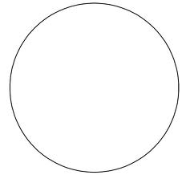

Name___________________________ Phone Number_________________

Pack #____________City_____________________Rank_______________

Send to: California Inland Empire Council, 1230 Indiana Ct., Redlands CA 92374

