

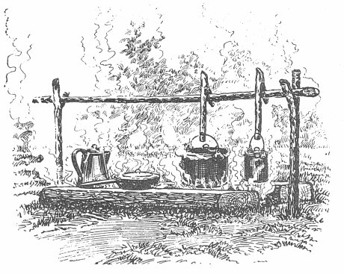
Come to Grayback District’s 40th Pop Nye Camporee
Then leave the cooking and cleaning to us.
Get a great Breakfast, Lunch, and Steak Dinner
For only $17.00 per person
(Steak Dinner only, $10.00 per person)
Special diet needs can be accommodated
Open to all non-competing personnel
This is wilderness dining so, BYO plates, cup & utensils
Wash area will be provided
Name……………………………..
Troop/Team/Crew/ Pack # ………
Full Meal tickets ………
Steak Dinner (only) tickets …..…..
Ticket purches deadline is 3/13/14 at Grayback District Roundtable
or 4/03/14 by mail
Make all payments to Bob or Carolyn Stanley
PLEASE! Do not make payment at Council Office
For RSVP or more information contact Bob Stanley at
grubmaster01@gmail.com or 951-533-2148


