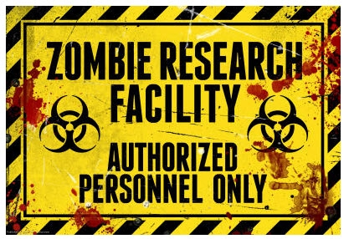
Green Zone 11
Emergency Preparedness
& Zombie Apocalypse
Nov. 8th or 9th, 2014
Sat 11am-5pm, Sun 11am- 5pm
Green Zone 11 (AKA Crossroads Riverview Park)
14600 Baron Dr, Corona, CA 92880
Emergency Preparedness Event – Zombie Apocalypse at Green Zone 11- For Scouts, friends and family (open to the public)
In this fun and educational event we will give scouts and non-scouts ways to be prepared in a real-life emergency. Using the pop culture awesomeness of a zombie apocalypse, we present an immersive and interactive theatrical environment that portrays a community of human survivors in the aftermath of a catastrophe (in this case a zombie apocalypse). Themed vendors display their goods, survival gear, crafts of all kinds, games of skill like archery, interactive survival techniques, pre-industrial technologies, displays of sustainable living and alternate power generating technology demonstrations. Learn first aid and disaster preparedness in workshops presented by the Red Cross and other groups. Become a CDC Zombie Research Scientist to learn more about zombies, in the zombie awareness arena. Learn how to create survival gear by recycling, foraging for food in the wild and much more. For the Scouts there will be specific stations to stop at to earn your patch program: there is a special patch designed just for the event. For everyone else, friends or family it’s just a day of pure fun, walking through a world of adventure they will never forget. There are other activities coming up too- Monster Make-up demonstrations, Spam cooking contest, and maybe even a Zombie 5k run! We are also a sponser of Scouting For Food! Please bring a bag of food to donate!!
So come, Scouts, friends and family to experience street theater, music and dance, food and drink, survival demonstrations and zombies, all while surrounded by the weird and wonderful denizens of this Strange New World. Survivors, please come dressed appropriately for survival if you would like to- (picture Mad Max, Steam Punk or The Walking Dead). See if you can continue to survive or become infected. Welcome to Green Zone 11!
Scouts please sign up by August so we have enough people to run all the booths. We need troops to attend AND volunteers too. Please email Vicki for more info.
Prices: Scouts attending for patch program- $17, Scouts as volunteers- $10,
General Public- $15
More info to come: Check out our Facebook page- like us and share with everyone. Check back weekly- more venders and activities will be added daily. https://www.facebook.com/pages/Green-Zone-11-Zombie-Apocalypse-Event-for-Scouts-and-Families/257155234461533
Questions? Email Vicki at: zombies.vicki@aol.com

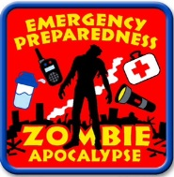

Green Zone 11 Scout
Emergency Preparedness
& Zombie Apocalypse

When: Sat Nov 8th OR Sun Nov 9th, 2014
Time: 11am-5pm.
Registration for Scouts 10:30-11am
Where: Green Zone 11 (AKA Crossroads Riverview Park)
14600 Baron Dr, Corona, CA 92880
Why register early? We need to know how many volunteers to have AND each participant will receive a patch and small survival kit.
----------------------------------------------------------------------------------------------------
REGISTRATION DUE BY August 1st 2014 (to assure a patch and survival kit)
Please write legibly!!
Troop Type_______ Troop number ______Level ages_____________
Which day are you coming? Nov 8th or Nov 9th? (Please circle one)
Leader_______________________________________
Phone: ___________________ Email_____________________________________
# of Scouts doing program: _____ x $17.00 = $_________
# of Scouts as volunteers: _____ x $10.00 = $_________
# of friends or family: _____ x $15.00 = $_________
# of extra Custom Patches: _____ x $2 = $_________
Total Due: $________________
Up to 2 adults accompanying troops, can have free admission with a bag of canned food for Second Harvest Food Bank
Make 1 Troop Check payable to: Girl Scout Troop 499
Mail registration & check to:
Vicki Woods 2336 E. Valley Glen Orange Ca 92867
Cell phone: 714 402-4569
Email: zombies.vicki@aol.com
Yes- Tickets available at gate- but you will not receive a survival kit.
Please email me with ANY questions! :0

