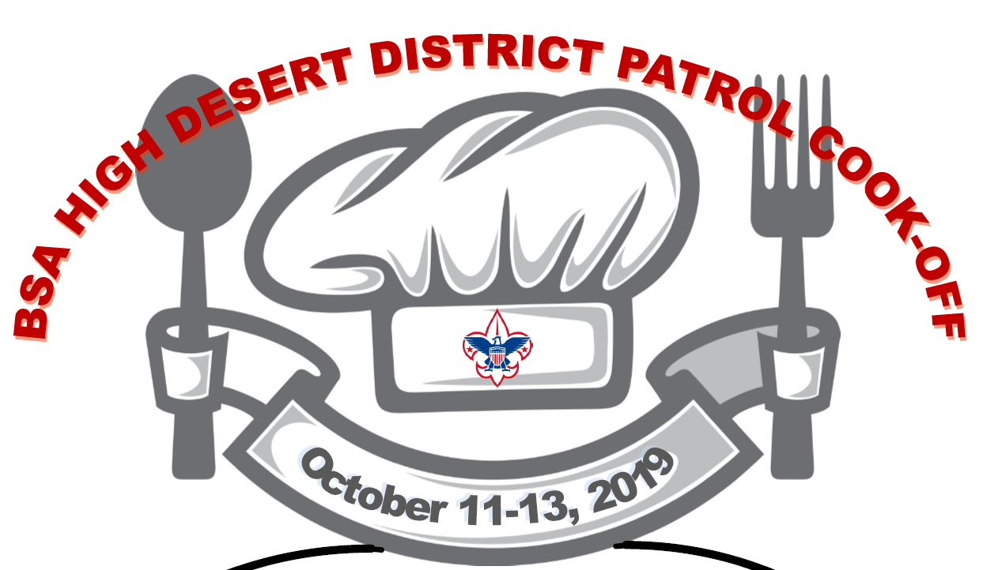

Leader Guide

Patrol Cookoff

Welcome to the Patrol Cookoff! This patrol-based camping event that will challenge your culinary skills while competing against other Scouts in a variety of categories. The program this year promises to be a great event. We have something planned for everyone: physical competitions, team building exercises, and more. Saturday’s events will also include the much-anticipated cooking competitions for breakfast, lunch, and dinner (including desert). There will be a campfire on Saturday night that will be a memorable event for all. Sunday morning will include a special Scout’s Own followed by a closing flag ceremony. We hope your unit will have a great time at this year’s event. The information attached and below will help you and your scouts to have a fun-filled weekend.

General Information

- The competition is open to Boy Scout, Venture Scout, Scouts, and Second year Webelos and Adult leaders. A patrol can only consist of members from the same category (e.g. all Boy Scouts, all Webelos, all Adult leaders, etc.).
- Units can have more than one Patrol compete in the cooking competition. Patrol size should be 6-8 scouts as recognized by the Scouting program. Patrol sized teams tend to work best.
- All Patrols should follow BSA Patrol structure. A designated PL or APL may be called upon to participate in Camp meetings to relay information to their Patrols.
- Check-in will begin at 6:00 p.m. on Friday at the entrance to Hesperia Lakes near the Equestrian area. The entire unit must be present upon check-in with the completed A&B medical and consent forms. Units should arrive in class-A uniform.
- All units should be checked in by 8:00pm – late check-ins will need to check in with camp staff.
- Recommend all personal and unit gear be labeled/taped with your name and unit number.
- All participants can wear Class B shirts during the competition and fun and games. The uniform for flags, campfire and Scouts Own is Class A.
- Positive Scout Spirit is expected at all times. Inappropriate behavior will result in the misbehaving individual being removed from Camp
- Dehydration is always a concern at camp, even when it is cold outside. Everyone should bring a water bottle to carry with them. All Units should provide sufficient water supplies for their Patrols.
- All units should be checked out with camp staff by 10:00am.

Camping Information

- Camp will be located north of the soccer fields and equestrian area. Units and Patrols will be assigned to a particular area to form a horseshoe shape. All tents should be placed to the rear of the site. All patrol boxes and kitchens should be established to the front. See diagram at end of the leader guide for guidance.
- All patrols will need to establish a patrol campsite according to BSA guidelines.
- Each patrol will be responsible for establishing a kitchen area with adequate food storage, cooking utensils, patrol box, cleaning supplies, etc.
- The Scout handbook contains checklists for camping gear. Please review it with all your Scouts. Remember weather can be unpredictable. Plan accordingly and check the weather prior to leaving. The event will go on, wind, rain or shine. Be prepared.

- Each patrol should have a message board within their campsite. Patrols should bring a whiteboard or some way to display duty rosters, menus, patrol rosters, map of camp, fireman’s chart, etc.
- All Patrols should come equipped with 3 legible copies of their patrol rosters. One to be displayed in camp, one to provide to camp staff on check-in and one provide to competition judges during camp challenges and games. A blank roster is included in this guide.
- Before checking out, all units will have their campsite inspected. Following inspection, units will be dismissed.

Cooking

- All meals are to be planned and prepared by each individual patrol, on their own prior to arrival. Patrols may want to have some granola bars/snacks available to tide the boys over between meals and until they get home.
- Proper meal planning is the key to reducing waste. At no time is it acceptable to dump leftover food or waste onto the ground or into the sinks or toilets. Each Patrol should have sufficient waste collection for their respective campsite. Patrols will need to provide their own trash bag. Patrols are to empty their trash after each meal and ensure that trash is not left out for the critters at night.
- Patrols will plan and prepare their own meals at Patrol Cookoff. The Scouts should conduct all menu planning and the food preparation as well. All planning can and should be done in advance. Adult participation should be limited to oversight only to insure Scout safety.
- Propane stoves and grills are allowed. Use of open fires must comply with all BSA policies on fire safety, local park rules and other regulations. If you plan a meal using charcoal, please plan a backup as well! Charcoal ash must be cold out and disposed of in a trash can, not dumped onto the ground.
- The kitchen area of your camp should be set up in accordance with the best practices laid out in the Boy Scout Handbook. See attached diagram for specific directions.
- Food must be stored in appropriate containers at all times (plastic totes, tubs with lids, etc) to avoid unwanted visits from wildlife.
- Units must use the three-pot sanitizing process recommended by the BSA

No matter how you’re cooking, you should have hot water for clean up by the time you’re done eating. Begin cleaning up by setting out three pots:
  - Wash pot – Contains hot water with a few drops of biodegradable soap.
  - Hot rinse pot – Clear, hot water.
  - Cold rinse pot – Cold rinse with a sanitizing tablet or a few drops of bleach to kill bacteria.

NO food is allowed inside tents at any time

- Each Patrol will prepare each meal. A plate of the meal will be prepared for presentation to the judges for sampling and evaluation.
- Plan the timing of your meals to coincide with the judging so it is hot and fresh! Points will not be deducted if your meal has cooled while waiting to be judged but they will if it has sat out a long time prior to judging.
- Breakfast and Lunch are “normal” meals.

- Dinner will also include a desert.
- Each meal presented for judging should be substantial enough to provide sampling by up to 5 judges.
- All of Saturdays meals will be judged in several categories:
  - Plating and presentation (appearance, name, and description)
  - Cooking technique (complexity and proficiency)
  - Full Meal Deal (well-balanced food groups)
  - Taste
  - Scout Theme
- Breakfast on Sunday will not be judged and should be an easy prep/cleanup meal to allow everyone to pack up and check out.
- Friday night there will be a pot-luck cracker barrel at 9:00pm. There will be no judging of the items brought for cracker barrel. It is a time for camaraderie, Scout fun, and recipe and experience sharing. All patrols should bring something to share and enjoy.

Cooking Merit Badge

- Cooking Merit Badge counselor(s) will be available to sign off on completed portions of the cooking Merit Badge.
- Due to the extensive nature of the cooking merit badge, it is impossible to complete all of the requirements during this one event. NO COMPLETED MERIT BADGE BLUE CARDS WILL BE ISSUED, ONLY PARTIAL COMPLETIONS.
- All Scouts should comply with all BSA policies and procedures for commencing a merit badge program.
- Contact with the merit badge counselors must always comply with Youth Protection guidelines.
- Please see attached Merit Badge Information page at end of leader guide for further information.

Camp Fun, Games and Challenges

- Between breakfast and lunch and between lunch and dinner there will be the opportunity for each Patrol to participate in a variety of fun, games and challenges.
- Participating in the events is not mandatory but is strongly recommended as they build strong patrol functions, comradery, teamwork and Scout Spirit. It will be assumed that all patrols will be participating. If a Patrol is opting to not participate, they must inform camp staff before 8pm on Friday.
- Class B dress for all games. Closed toed shoes required.
- A schedule and description of events will be distributed upon check-in.
- Positive Scout Spirit and good sportsmanship is required during all Camp fun, games and challenges. Inappropriate behavior will result in the offender being removed from Camp.
- ONE CHALLENGE REQUIRES UNITS TO PROVIDE KINDLING AND A SAFE PLACE FOR IGNITION. IT IS RECCOMENDED THAT UNITS HAVE A SUPPLY OF SAND OR GRAVEL OR EVEN A METAL TRASH CAN LID ON WHICH A SMALL FIRE CAN BE IGNITED.

Camp Competitions & Awards

- As this is a Scout challenge competition, awards and recognition will be earned in a variety of categories. These recognitions are meant to encourage the competitive spirits of the Scouts and to encourage Scouts to live up to the great standards of scouting and the benefits of the patrol method. Recognitions are subject to change at the discretion of the camp staff to meet the needs of the event and the number of participants. The following list of recognitions is provided as a guide only to provide encouragement:
  - Best individual meals (breakfast, lunch and dinner/desert)
  - Best kitchen (organization, cleanup, work station, team work, scout spirit)
  - Best overall meal
  - Best techniques
  - Best Scout Theme
  - Best Balanced meals
  - Winners of the various competitions and games
  - Scout Spirit, Leadership & Teamwork

Camp Expectations
- No alcohol is allowed (even as an ingredient).
- Youth Protection will be observed at all times.
- All adults attending camp must have completed and up to date Youth Protection Training prior to Camp.
- Smoking in designated areas only; and at no time in the camping or cooking areas.
- Buddy system at all times.
- No running in camp unless asked to do so in a program area.
- Treat others with respect, including youth staff - address issues/concerns with adult staff and not the youth staff.
- Do not throw any trash, food or other materials into the Lake.
- Adhere to all parking policies, carpool as much as possible.
- All Scouts and Scouters will conduct themselves with the Outdoor Code in mind.
- Always conduct yourself with the Scout Oath and Law in mind
- Your entire Patrol participates in the activities provided on Saturday.
- Your units check out Sunday morning after closing flag unless previously arranged with the Camp Director.
Please share this information with everyone in your unit that is attending Top Patrol Cookoff

We look forward to seeing you on at Top Patrol Cookoff as we challenge our fellow Scouts in outdoor cooking and we share in the camaraderie of the Scouting Program.

Cooking Merit Badge Information Attachment

Note: The meals prepared for Cooking merit badge requirements 4, 5, and 6 will count only toward fulfilling those requirements and will not count toward rank advancement or other merit badges. Meals prepared for rank advancement or other merit badges may not count toward the Cooking merit badge. You must not repeat any menus for meals actually prepared or cooked in requirements 4, 5, and 6.
Health and safety. Do the following:

a. Explain to your counselor the most likely hazards you may encounter while participating in cooking activities and what you should do to anticipate, help prevent, mitigate, and respond to these hazards.
b. Show that you know first aid for and how to prevent injuries or illnesses that could occur while preparing meals and eating, including burns and scalds, cuts, choking, and allergic reactions.
c. Describe how meat, fish, chicken, eggs, dairy products, and fresh vegetables should be stored, transported, and properly prepared for cooking. Explain how to prevent cross-contamination.
d. Discuss with your counselor food allergies, food intolerance, and food-related illnesses and diseases. Explain why someone who handles or prepares food needs to be aware of these concerns.
e. Discuss with your counselor why reading food labels is important. Explain how to identify common allergens such as peanuts, tree nuts, milk, eggs, wheat, soy, and shellfish.
Nutrition. Do the following:

Using the MyPlate food guide or the current USDA nutrition model, give five examples for EACH of the following food groups, the recommended number of daily servings, and the recommended serving size:
1. Fruits
2. Vegetables
3. Grains
4. Proteins
5. Dairy

3. Cooking basics. Do the following:
a. Discuss EACH of the following cooking methods. For each one, describe the equipment needed, how temperature control is maintained, and name at least one food that can be cooked using that method: baking, boiling, broiling, pan frying, simmering, steaming, microwaving, grilling, foil cooking, and use of a Dutch oven.
b. Discuss the benefits of using a camp stove on an outing vs. a charcoal or wood fire.
c. Describe for your counselor how to manage your time when preparing a meal so components for each course are ready to serve at the correct time.

5. Camp cooking. Do the following:
a. Using the MyPlate food guide or the current USDA nutrition model, plan five meals for your patrol (or a similar size group of up to eight youth, including you) for a camping trip. Your menus should include enough food for each person, keeping in mind any special needs (such as food allergies) and how you keep your foods safe and free from cross-contamination. These five meals must include at least one breakfast, one lunch, one dinner, AND at least one snack OR one dessert. List the equipment and utensils needed to prepare and serve these meals.
b. Create a shopping list for your meals showing the amount of food needed to prepare and serve each meal, and the cost for each meal.
c. Share and discuss your meal plan and shopping list with your counselor.

d. In the outdoors, using your menu plans for this requirement, cook two of the five meals you planned using either a lightweight stove or a low-impact fire. Use a different cooking method from requirement 3 for each meal. You must also cook a third meal using either a Dutch oven OR a foil pack OR kabobs. Serve all of these meals to your patrol or a group of youth. **
e. In the outdoors, prepare a dessert OR a snack and serve it to your patrol or a group of youth.**
f. After each meal, have those you served evaluate the meal on presentation and taste, and then evaluate your own meal. Discuss what you learned with your counselor, including any adjustments that could have improved or enhanced your meals. Tell how planning and preparation help ensure successful outdoor cooking.
g. Explain to your counselor how you cleaned the equipment, utensils, and the cooking site thoroughly after each meal. Explain how you properly disposed of dishwater and of all garbage.
h. Discuss how you followed the Outdoor Code and no-trace principles when preparing your meals.

7. Food-related careers. Find out about three career opportunities in cooking. Select one and find out the education, training, and experience required for this profession. Discuss this with your counselor, and explain why this profession might interest you.

Each Scout that is interested in working on Cooking MB should have a properly filled out Blue Card when working with the counselor. Scouts, without a properly filled out Blue Card and signed by Scoutmaster will not be able to get requirements signed off.

TENTATIVE PATROL COOKOFF SCHEDULE

FRIDAY
6:00PM - 8:00PM Check-in (Field/Class A Uniforms)
6:00PM - 8:45PM Set up & prep Cracker Barrell
8:30PM Event meeting for adult leaders, PL & APLs
9:00PM Pot-Luck Cracker Barrel
10:00PM Lights Out

SATURDAY
6:30AM Reveille
6:30AM – 8:00AM Breakfast & Clean-up
7:00AM – 8:30AM Judging for breakfast (ongoing as meals are completed)
8:30AM Opening Flag (Class A Uniforms)
9:00AM – 11:00AM Morning Activities
11:00AM – 12:30PM Lunch & Clean-up
11:30AM – 12:30PM Judging for lunch (ongoing as meals are completed)
1:00PM – 4:00PM Afternoon Activities
4:00PM – 5:00PM Patrol Time
5:00PM – 6:30PM Dinner & desert & Clean-up
5:30PM – 6:30PM Judging for dinner and desert (ongoing as meals are completed)
8:00PM – 9:00PM Campfire & Awards
9:00PM Cracker Barrel
10:00PM Lights Out

SUNDAY
7:00AM Reveille
7:00AM – 7:50AM Breakfast & Clean-up
8:00AM – 8:30AM Scout’s Own Interfaith Worship Service - Remember, A Scout is Reverent!! (Class A Uniforms)
8:45AM – 9:15AM Closing Flags (Class A Uniforms)
9:30AM Unit check out. (All camp areas must be inspected by a staff member for cleanliness).
All Units must exit the camp by 10:00 AM Sunday
Please respect our camp and fellow Scouters... please leave no trace behind!

Patrol Cookoff Patrol Roster

Patrol Name: ______ Date of the event:

Patrol Leader:

Assistant Patrol Leader:

Chaplain Aide:

Fire Warden:

Quartermaster:

Patrol Member:

Patrol Member:

Patrol Member:

Patrol Member:

Patrol Member:

Patrol Member:

Patrol Member:

Primary Adult Contact: Alternate Adult Contact:

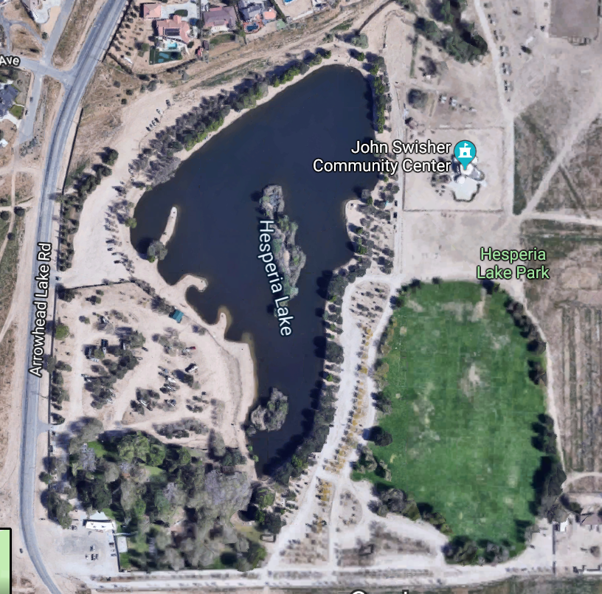
Camping area

Scout Unit
Troops will be assigned a designated spot in the dirt lot. Troop tents are to be the exterior with the patrol boxes (kitchen) on the interior facing towards the center of the field. The patrol boxes will serve as a focal point and a way for the judges to quickly walk past all sites and observe.

Scout Unit
Scout Unit

Patrol Box
Patrol Box
Patrol Box

Scout Unit
Patrol Box

Patrol Box
Patrol Box

Scout Unit
Scout Unit

